UNITED STATES
SECURITIES AND EXCHANGE COMMISSION
Washington, D.C. 20549

SCHEDULE 14A INFORMATION

Proxy Statement Pursuant to Section 14(a) of the
Securities Exchange Act of 1934

Filed by the Registrant x Filed by a Party other than the Registrant o

Check the appropriate box:

o |  |  | Preliminary Proxy Statement
o |  |  | Confidential, for Use of the Commission Only (as permitted by Rule 14a-6(e)(2))
o |  |  | Definitive Proxy Statement
x |  |  | Definitive Additional Materials
o |  |  | Soliciting Material under §240.14a-12
GUIDEWIRE SOFTWARE, INC.
(Name of registrant as specified in its charter)
(Name of Person(s) Filing Proxy Statement, if other than the Registrant)
Payment of Filing Fee (Check all boxes that apply):
x |  |  | No fee required
o |  |  | Fee paid previously with preliminary materials
o |  |  | Fee computed on table in exhibit required by Item 25(b) per Exchange Act Rules 14a-6(i)(1) and 0-11

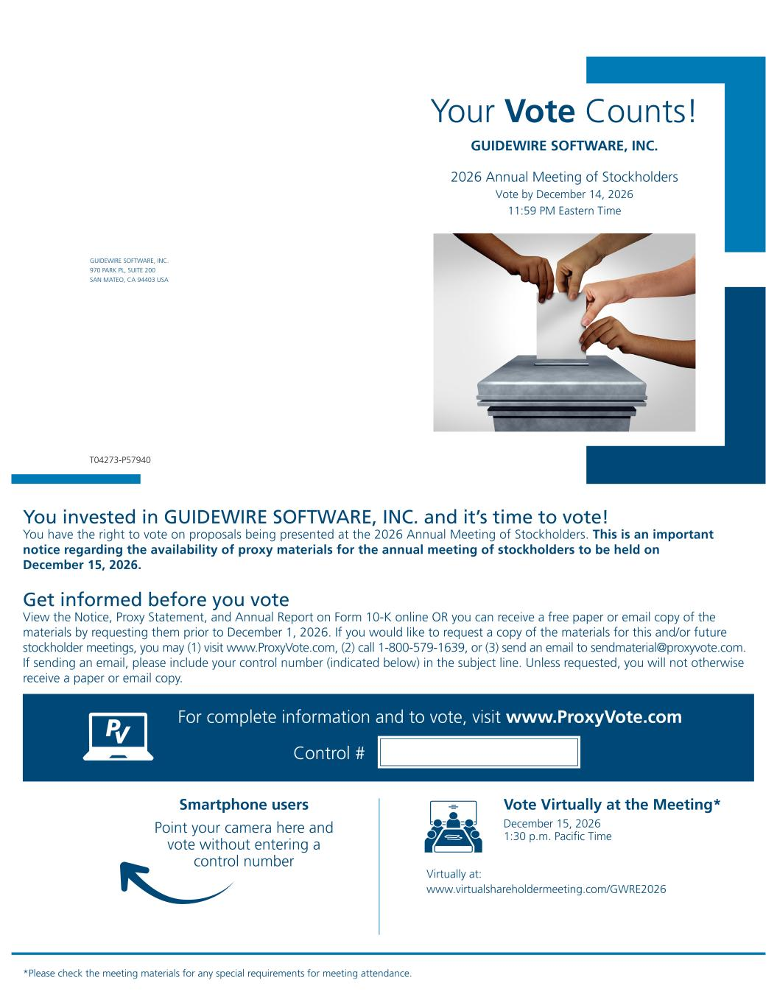

Your Vote Counts! GUIDEWIRE SOFTWARE, INC. 2026 Annual Meeting of Stockholders Vote by December 14, 2026 11:59 PM Eastern Time You invested in GUIDEWIRE SOFTWARE, INC. and it’s time to vote! You have the right to vote on proposals being presented at the 2026 Annual Meeting of Stockholders. This is an important notice regarding the availability of proxy materials for the annual meeting of stockholders to be held on December 15, 2026. Vote Virtually at the Meeting* December 15, 2026 1:30 p.m. Pacific Time Virtually at: www.virtualshareholdermeeting.com/GWRE2026 *Please check the meeting materials for any special requirements for meeting attendance. Smartphone users Point your camera here and vote without entering a control number For complete information and to vote, visit www.ProxyVote.com Control # T04273-P57940 Get informed before you vote View the Notice, Proxy Statement, and Annual Report on Form 10-K online OR you can receive a free paper or email copy of the materials by requesting them prior to December 1, 2026. If you would like to request a copy of the materials for this and/or future stockholder meetings, you may (1) visit www.ProxyVote.com, (2) call 1-800-579-1639, or (3) send an email to sendmaterial@proxyvote.com. If sending an email, please include your control number (indicated below) in the subject line. Unless requested, you will not otherwise receive a paper or email copy. GUIDEWIRE SOFTWARE, INC. 970 PARK PL, SUITE 200 SAN MATEO, CA 94403 USA

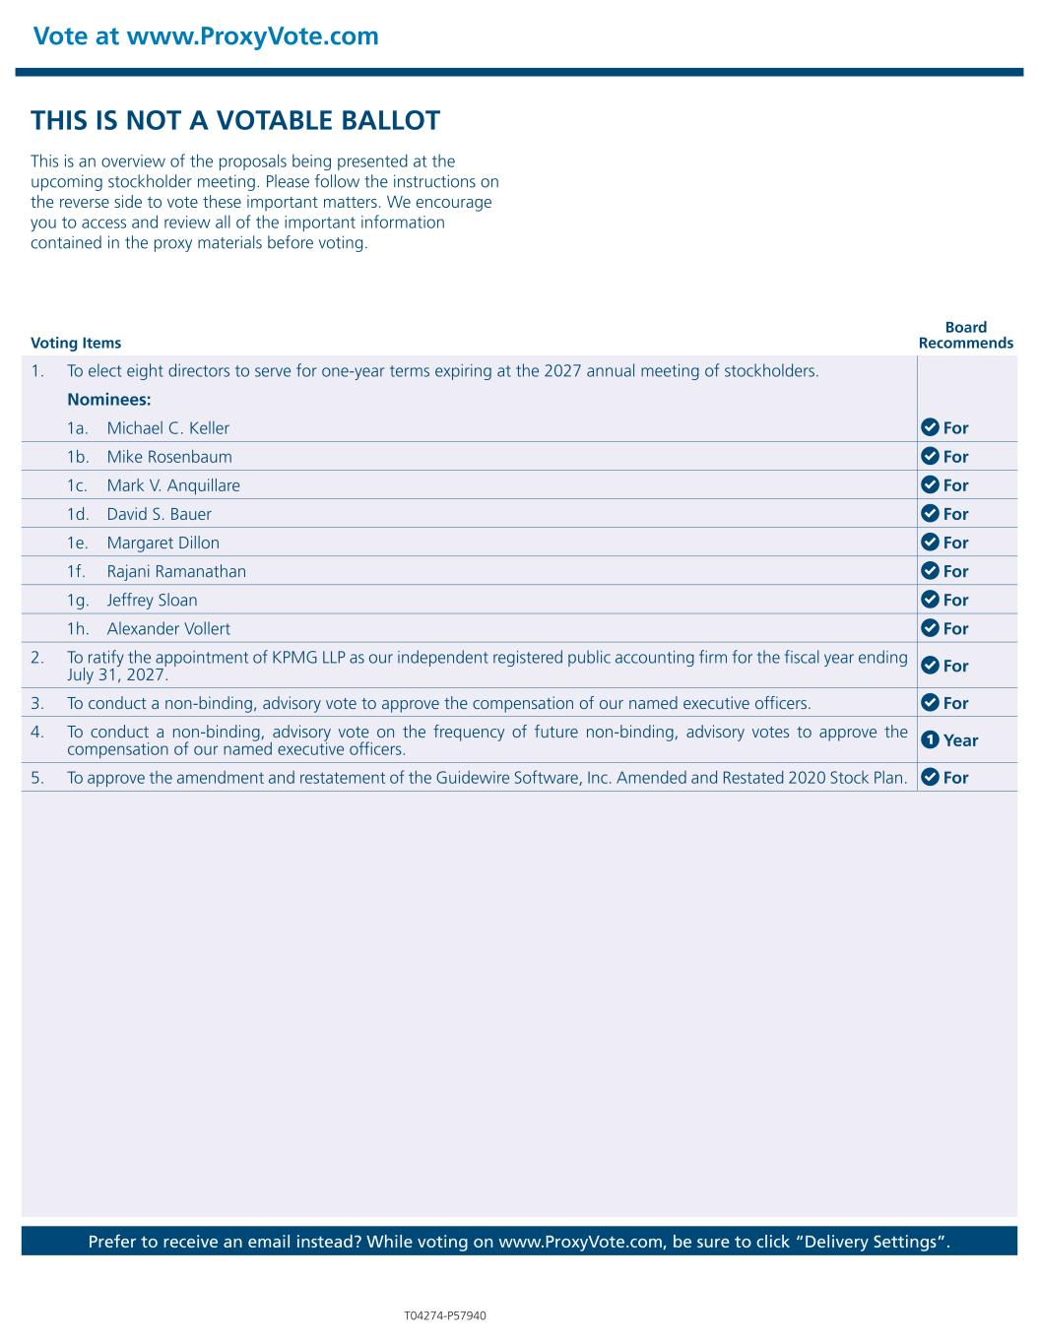
THIS IS NOT A VOTABLE BALLOT This is an overview of the proposals being presented at the upcoming stockholder meeting. Please follow the instructions on the reverse side to vote these important matters. We encourage you to access and review all of the important information contained in the proxy materials before voting. Vote at www.ProxyVote.com Prefer to receive an email instead? While voting on www.ProxyVote.com, be sure to click “Delivery Settings”. Voting Items Board Recommends T04274-P57940 1. To elect eight directors to serve for one-year terms expiring at the 2027 annual meeting of stockholders. Nominees: 1a. Michael C. Keller For 1b. Mike Rosenbaum For 1c. Mark V. Anquillare For 1d. David S. Bauer For 1e. Margaret Dillon For 1f. Rajani Ramanathan For 1g. Jeffrey Sloan For 1h. Alexander Vollert For 2. To ratify the appointment of KPMG LLP as our independent registered public accounting firm for the fiscal year ending July 31, 2027. For 3. To conduct a non-binding, advisory vote to approve the compensation of our named executive officers. For 4. To conduct a non-binding, advisory vote on the frequency of future non-binding, advisory votes to approve the compensation of our named executive officers. 1 Year 5. To approve the amendment and restatement of the Guidewire Software, Inc. Amended and Restated 2020 Stock Plan. For

