UNITED STATES
SECURITIES AND EXCHANGE COMMISSION
Washington, D.C. 20549
_______________________________________________________________
FORM 8-K
_______________________________________________________________
CURRENT REPORT

Pursuant to Section 13 or 15(d) of the
Securities Exchange Act of 1934

Date of Report (Date of earliest event reported): July 17, 2026
_______________________________________________________________
Guidewire Software, Inc.
(Exact name of registrant as specified in its charter)
_______________________________________________________________
Delaware |  |  |  |  |  | 001-35394 |  |  |  |  |  | 36-4468504
(State or other jurisdiction of incorporation) |  |  |  |  |  | (Commission File Number) |  |  |  |  |  | (I.R.S. Employer Identification No.)

970 Park Pl, Suite 200
San Mateo, CA 94403
(Address of principal executive offices, including zip code)

(650) 357-9100
(Registrant’s telephone number, including area code)

Not applicable
(Former name or former address, if changed since last report)

Check the appropriate box below if the Form 8-K filing is intended to simultaneously satisfy the filing obligation of the registrant under any of the following provisions:
☐ |  |  | Written communications pursuant to Rule 425 under the Securities Act (17 CFR 230.425)
☐ |  |  | Soliciting material pursuant to Rule 14a-12 under the Exchange Act (17 CFR 240.14a-12)
☐ |  |  | Pre-commencement communications pursuant to Rule 14d-2(b) under the Exchange Act (17 CFR 240.14d-2(b))
☐ |  |  | Pre-commencement communications pursuant to Rule 13e-4(c) under the Exchange Act (17 CFR 240.13e-4(c))

Securities registered pursuant to Section 12(b) of the Act:
Title of each class |  |  | Trading Symbol(s) |  |  | Name of each exchange on which registered
Common Stock, $0.0001 par value |  |  | GWRE |  |  | New York Stock Exchange

Indicate by check mark whether the registrant is an emerging growth company as defined in Rule 405 of the Securities Act of 1933 (§230.405 of this chapter) or Rule 12b-2 of the Securities Exchange Act of 1934 (§240.12b-2 of this chapter).
Emerging growth company ☐
If an emerging growth company, indicate by check mark if the registrant has elected not to use the extended transition period for complying with any new or revised financial accounting standards provided pursuant to Section 13(a) of the Exchange Act. ☐

Item 5.02 Departure of Directors or Certain Officers; Election of Directors; Appointment of Certain Officers; Compensatory Arrangements of Certain Officers.
On July 17, 2026, the Board of Directors (the “Board”) of Guidewire Software, Inc. (the “Company”) appointed Alexander Vollert as a director of the Board, effective as of August 1, 2026. Dr. Vollert’s initial term will run through the Company’s 2026 annual meeting of stockholders, subject to his being re-elected at that meeting.
Dr. Vollert has served as a Senior Advisor to the Group Management Committee at AXA SA since January 2026. From December 2021 through December 2025, he served as Chief Operating Officer of AXA SA, during which time he was also a member of AXA SA’s Group Management Committee, and Chief Executive Officer of AXA Group Operations SAS, a subsidiary of AXA SA. From September 2016 to November 2021, he served as Chief Executive Officer of AXA Germany (AXA Konzern AG).
There are no arrangements or understandings between Dr. Vollert and any other person pursuant to which he was appointed as a director of the Company. Dr. Vollert has no family relationship with any director or executive officer of the Company. During the Company’s fiscal year ended July 31, 2025, and for the nine months ended April 30, 2026, the Company recognized approximately $11.3 million and $13.4 million, respectively, in revenue for services provided to AXA SA and all its global affiliates in the ordinary course of business. As noted above, Dr. Vollert was an executive at AXA SA and one of its subsidiaries through December 2025. Dr. Vollert is otherwise not a party to any transaction required to be disclosed pursuant to Item 404(a) of Regulation S-K.
Dr. Vollert will be provided with the Company’s standard non-employee director compensation and director indemnification agreement.
On July 22, 2026, the Company issued a press release announcing the appointment of Dr. Vollert as a director. A copy of this press release is furnished as Exhibit 99.1 to this current report on Form 8-K.

Item 9.01 Exhibits.
(d) Exhibits.

Exhibit No. Description of Exhibits
99.1 Press release issued by Guidewire Software, Inc. on July 22, 2026
104 Cover Page Interactive Data File (embedded within the Inline XBRL document)

SIGNATURE
Pursuant to the requirements of the Securities Exchange Act of 1934, the registrant has duly caused this report to be signed on its behalf by the undersigned hereunto duly authorized.

GUIDEWIRE SOFTWARE, INC.
By: |  |  | /s/ JEFF COOPER
 |  |  | Jeff Cooper
 |  |  | Chief Financial Officer
Date: |  |  | July 22, 2026

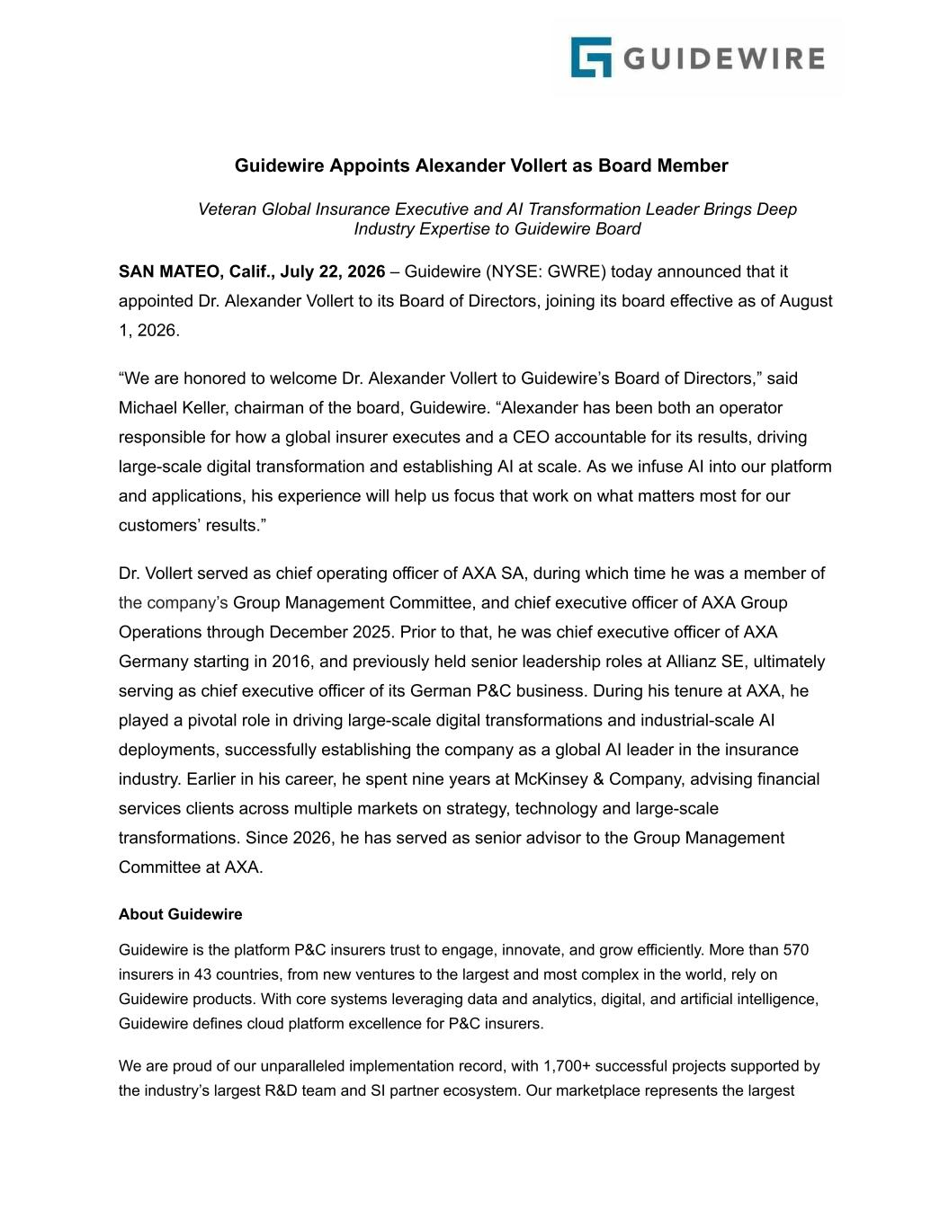

Guidewire Appoints Alexander Vollert as Board Member Veteran Global Insurance Executive and AI Transformation Leader Brings Deep Industry Expertise to Guidewire Board SAN MATEO, Calif., July 22, 2026 – Guidewire (NYSE: GWRE) today announced that it appointed Dr. Alexander Vollert to its Board of Directors, joining its board effective as of August 1, 2026. “We are honored to welcome Dr. Alexander Vollert to Guidewire’s Board of Directors,” said Michael Keller, chairman of the board, Guidewire. “Alexander has been both an operator responsible for how a global insurer executes and a CEO accountable for its results, driving large-scale digital transformation and establishing AI at scale. As we infuse AI into our platform and applications, his experience will help us focus that work on what matters most for our customers’ results.” Dr. Vollert served as chief operating officer of AXA SA, during which time he was a member of the company’s Group Management Committee, and chief executive officer of AXA Group Operations through December 2025. Prior to that, he was chief executive officer of AXA Germany starting in 2016, and previously held senior leadership roles at Allianz SE, ultimately serving as chief executive officer of its German P&C business. During his tenure at AXA, he played a pivotal role in driving large-scale digital transformations and industrial-scale AI deployments, successfully establishing the company as a global AI leader in the insurance industry. Earlier in his career, he spent nine years at McKinsey & Company, advising financial services clients across multiple markets on strategy, technology and large-scale transformations. Since 2026, he has served as senior advisor to the Group Management Committee at AXA. About Guidewire Guidewire is the platform P&C insurers trust to engage, innovate, and grow efficiently. More than 570 insurers in 43 countries, from new ventures to the largest and most complex in the world, rely on Guidewire products. With core systems leveraging data and analytics, digital, and artificial intelligence, Guidewire defines cloud platform excellence for P&C insurers. We are proud of our unparalleled implementation record, with 1,700+ successful projects supported by the industry’s largest R&D team and SI partner ecosystem. Our marketplace represents the largest

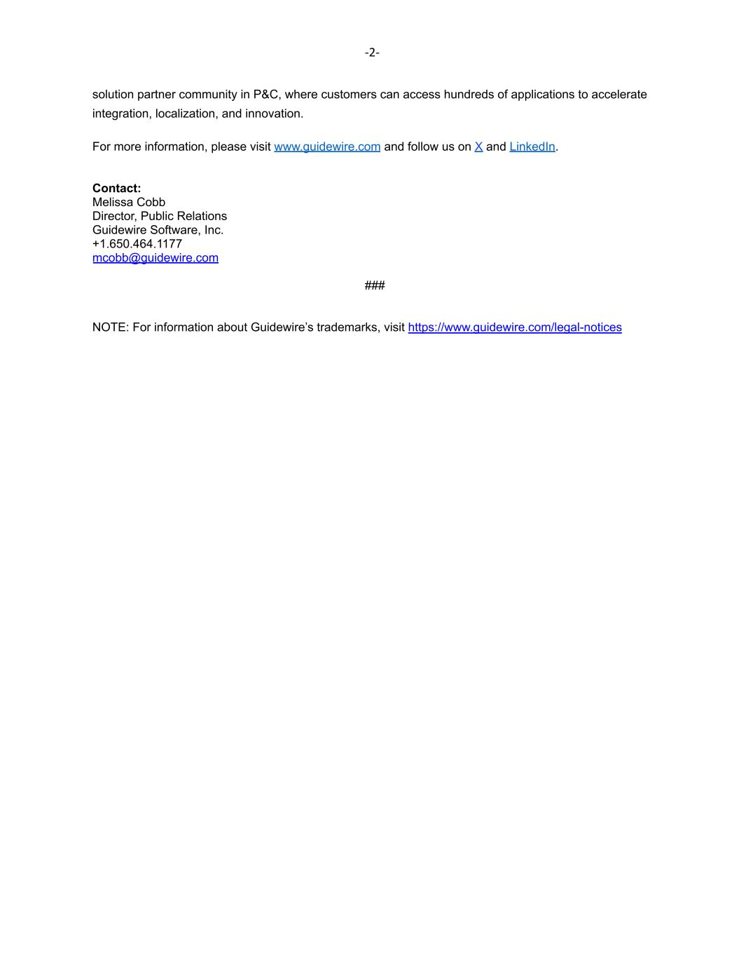
-2- solution partner community in P&C, where customers can access hundreds of applications to accelerate integration, localization, and innovation. For more information, please visit www.guidewire.com and follow us on X and LinkedIn. Contact: Melissa Cobb Director, Public Relations Guidewire Software, Inc. +1.650.464.1177 mcobb@guidewire.com ### NOTE: For information about Guidewire’s trademarks, visit https://www.guidewire.com/legal-notices

